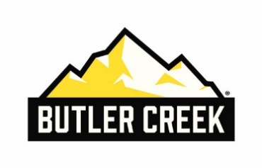
Contact: Matt Rice
Senior Manager Media Relations
(913) 689-3713
E-mail: Matt.Rice@VistaOutdoor.com

FOR IMMEDIATE RELEASE

Butler Creek® Unveils New Element Scope Caps
Modular, Rugged Caps Offer Customization and Uncompromising Protection

OVERLAND PARK, Kan. – March 15, 2021 – Butler Creek®, maker of smart, field-proven hunting and shooting accessories, announced today the launch of its new Element Scope Caps. Rugged and modular, Element Scope Caps are designed to protect almost any scope thanks to various size options and a multi-flex rubber sleeve design.
The Element Scope Cap comes with modular, interchangeable lens caps to choose from – clear disk, ballistic data disk or standard black disk. The ballistic data disk accepts a ballistic chart template insert, which can be downloaded and printed from the Butler Creek website. This gives shooters easy access to critical ballistics data in the field, providing them with all the information they need to make an accurate shot before pulling the trigger.
The lens caps are made from durable polymer to withstand heavy use in the field, including extreme hot and cold conditions. The caps flip open with the touch of a button, allowing hunters to protect their scope right up until that critical moment of opportunity. After being unlocked, the cap can be flipped 180 degrees to stand upright or 270 degrees to fold back onto the scope and out of the way.
The Element Scope Cap comes in eight different sizes to fit most scopes on the market. There are six objective lens cap options including 35-40mm, 40-45mm, 45-50mm, 50-55mm, 55-60mm and 60-65mm, as well as small (37-42mm) and large (42-47mm) eyepiece cap options. All of the new Butler Creek Element Scope Caps have an MSRP of $29.95.
For more information on this product or to view the complete line of Butler Creek products, visit www.butlercreek.com.

About Butler Creek
Butler Creek produces innovative, field-proven accessories that improve the shooting experience for hunters and tactical enthusiasts alike. The wide array of accessories are designed by shooters who know the value of quality and durability. With innovations that have expanded from the original Butler Creek Scope Caps, the product line now includes slings, straps, magazines and magazine loaders. To learn more, visit www.butlercreek.com or on Facebook at www.facebook.com/ButlerCreek/.

